**R Score- GridSearch CV Method**

**SVMR:**

The R_score value for best parameter {'C': 3000, 'gamma': 'scale', 'kernel': 'poly'}:

R_ score :0.8598930084494385

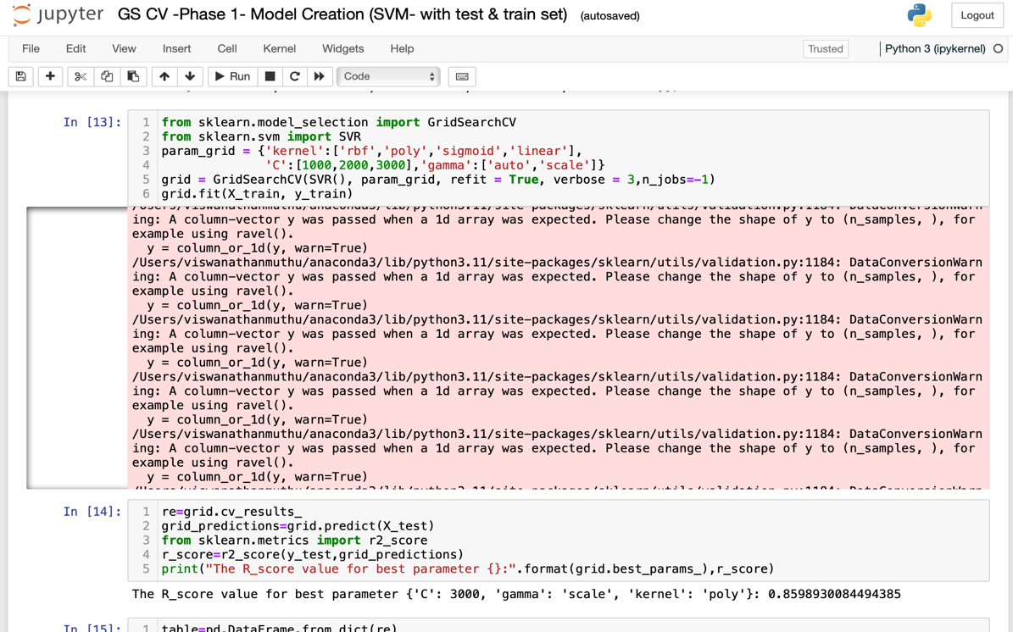

**DT :**

The R_score value for best parameter {'criterion': 'friedman_mse', 'max_features': 'sqrt', 'splitter': 'best'}:

R_ score :0.998667156135576

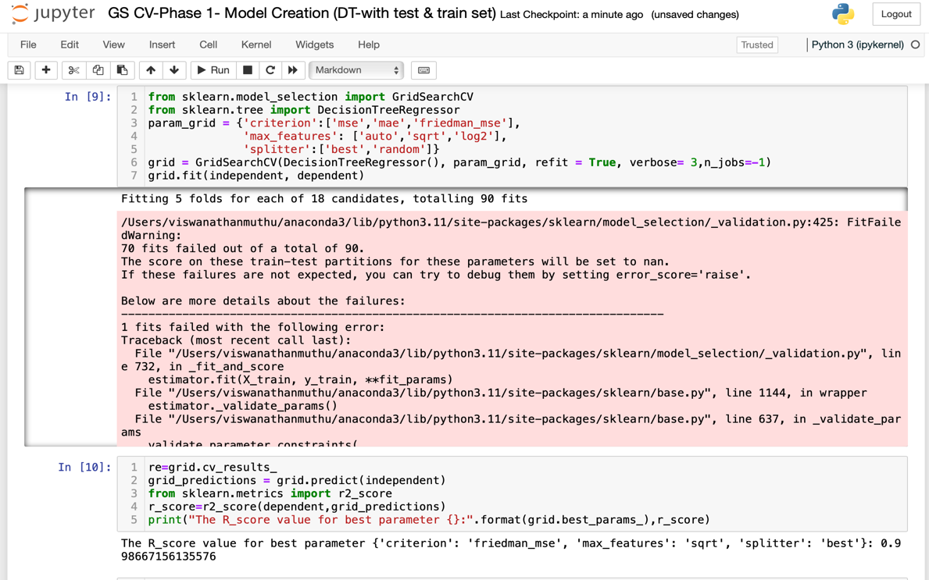

**RF:**

The R_score value for best parameter {'criterion': 'poisson', 'max_features': 'log2', 'n_estimators': 100}:

R_ score :0.8718102865527723

